**Sequence Diagram**

**Proposal for Employee Hiring Software to Prevent Favoritism**

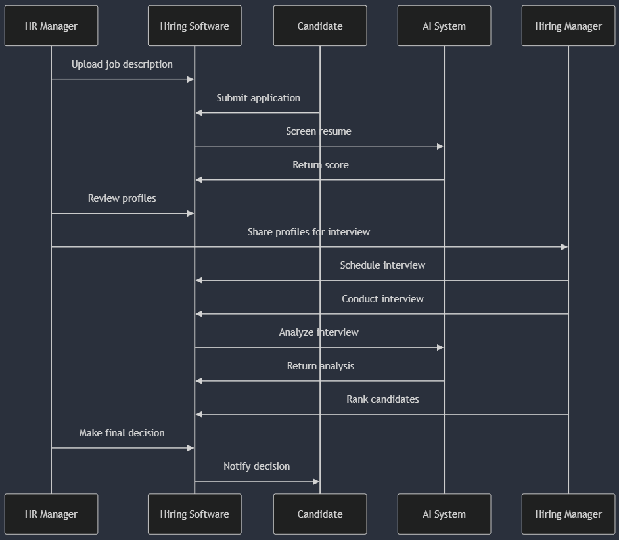

**Gantt chart**

**Proposal for Employee Hiring Software to Prevent Favoritism**

